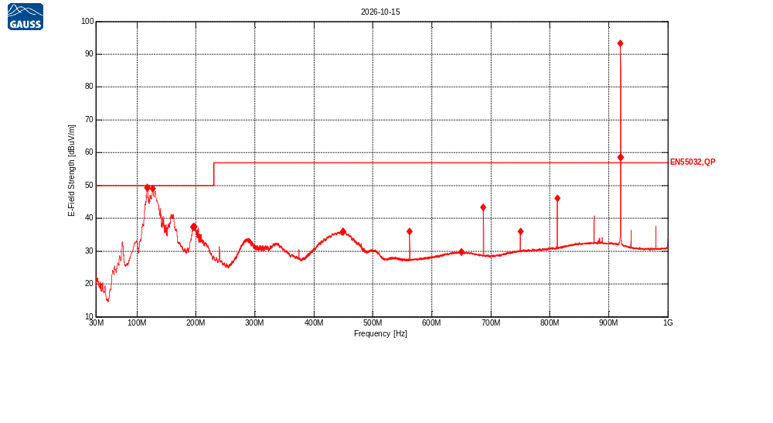
Receiver Model:
Protocol Number:
Serial Number:
Operation State:
Notes:
123123

Traces:
Trace | Start | Step | Stop | IF Bandwidth | Detector | Dwell time | Attenuation | Transducer | LISN | Notes
Scan2 | 30.0 MHz | 50.0 kHz | 1.0 GHz | 120kHz | QP | 200.0 ms | Auto | TDF1, TDF2, TDF3 | -

Transducers:
TDF1: Kabel Biru
TDF2: Heliax_Cable
TDF3: AaroniaHyperLog20600V (30M - 6GHz)

Limit lines:
EN55032,QP: EN55032 Rad 3m,Class A,OATS/SAC,QP, 30MHz-1000MHz
Scan2: 30.0 MHz, 50.0 kHz, 1.0 GHz; IF:120kHz, 200.0 ms QP, Att AutodB
f | Mag [dBuV/m] | Limit | Diff | Polarization | Height [cm] | Angle [°] | Trans | Name | Comment
117.398142 MHz | 49.16 | 50.00 | 0.84 | H | 300 | 270 | 16.94 | EN55032,QP
117.8864 MHz | 49.49 | 50.00 | 0.51 | H | 300 | 270 | 16.99 | EN55032,QP
126.821518 MHz | 49.05 | 50.00 | 0.95 | H | 300 | 90 | 21.43 | EN55032,QP
195.128781 MHz | 37.40 | 50.00 | 12.60 | H | 200 | 0 | 14.34 | EN55032,QP
195.324084 MHz | 37.29 | 50.00 | 12.71 | H | 200 | 0 | 14.35 | EN55032,QP
197.960676 MHz | 37.49 | 50.00 | 12.51 | H | 200 | 0 | 14.57 | EN55032,QP
449.315781 MHz | 35.90 | 57.00 | 21.10 | H | 100 | 45 | 19.20 | EN55032,QP
449.608735 MHz | 35.89 | 57.00 | 21.11 | H | 100 | 45 | 19.20 | EN55032,QP
449.755213 MHz | 35.90 | 57.00 | 21.10 | H | 100 | 45 | 19.20 | EN55032,QP
562.54276 MHz | 35.97 | 57.00 | 21.03 | V | 100 | 0 | 20.56 | EN55032,QP
649.892076 MHz | 29.82 | 57.00 | 27.18 | H | 100 | 240 | 22.72 | EN55032,QP
650.233857 MHz | 29.83 | 57.00 | 27.17 | H | 200 | 0 | 22.72 | EN55032,QP
687.536751 MHz | 43.35 | 57.00 | 13.65 | V | 100 | 0 | 22.02 | EN55032,QP
750.082573 MHz | 36.02 | 57.00 | 20.98 | V | 100 | 0 | 23.27 | EN55032,QP
812.579568 MHz | 46.09 | 57.00 | 10.91 | H | 300 | 255 | 24.00 | EN55032,QP
919.654499 MHz | 58.56 | 57.00 | -1.56 | H | 100 | 240 | 24.20 | EN55032,QP | Failed
920.045106 MHz | 93.29 | 57.00 | -36.29 | H | 100 | 255 | 24.19 | EN55032,QP | Failed
920.386886 MHz | 58.51 | 57.00 | -1.51 | H | 100 | 240 | 24.17 | EN55032,QP | Failed

